

GROUP BASED PROJECT
PROJECT TITLE:
Gym Management System
SUBJECT:
Database System
SECTION:
BSAI (4A)
GROUP MEMBERS:
Ayesha Noor (034) Leader
Aima Eirj (063)

ASSIGNMENT: 01
ERD Diagram and Theory

PROJECT DESCRIPTION
The Gym Management System is a database-driven application developed to efficiently manage gym operations such as member records, payments, attendance, trainers, and diet plans. The system replaces traditional manual methods with an automated solution that ensures accuracy, consistency, and fast data access.
OBJECTIVES
- Maintain complete member records
- Track payments efficiently
- Monitor daily attendance
- Assign diet plans and trainers
- Use automation (triggers & procedures)
- Ensure data integrity and consistency

DATABASE ENTITIES (TABLES)

1. Members
Purpose: Store information about gym members
Attributes:
- MemberID (Primary Key)
- Name
- Phone
- JoinDate
- MembershipType

2. Trainers
Purpose: Store trainer details
Attributes:
- TrainerID (Primary Key)
- Name
- Specialty

3. Plans
Purpose: Define membership plans
Attributes:
- PlanID (Primary Key)
- PlanName
- DurationMonths
- Fee

4. Payments
Purpose: Track member payments
Attributes:
- PaymentID (Primary Key)
- MemberID (Foreign Key)
- Amount
- PaymentDate
Relationship: One member can have multiple payments

5. Attendance
Purpose: Record daily attendance
Attributes:
- AttendanceID (Primary Key)
- MemberID (Foreign Key)
- Date
- Status

6. DietPlans
Purpose: Store different diet plans
Attributes:
- DietID (Primary Key)
- PlanName
- Goal (Weight Loss / Muscle Gain)
- Calories
- Protein
- Carbs
- Fats

7. MemberDiet
Purpose: Assign diet plans to members
Attributes:
- ID (Primary Key)
- MemberID (Foreign Key)
- DietID (Foreign Key)
- StartDate
Relationship: Many-to-Many (Members ↔ DietPlans)

RELATIONSHIPS

Members → Payments (One-to-Many)
One member can make multiple payments, but each payment is linked to only one member.

Members → Attendance (One-to-Many)
One member can have multiple attendance records, as attendance is recorded daily.

Members ↔ DietPlans (Many-to-Many)
A member can follow different diet plans over time, and one diet plan can be assigned to multiple members.
This relationship is managed using an intermediate table called MemberDiet.

Members → Trainers (One-to-Many)
One trainer can be assigned to multiple members, while each member has only one trainer.
The system uses one-to-many relationships between Members and Payments, Members and Attendance, and Trainers and Members. A many-to-many relationship exists between Members and DietPlans, which is resolved using the MemberDiet table. These relationships ensure proper data organization, integrity, and efficient management of gym operations.

PROBLEM STATEMENT WITH SOLUTIONS

Problem 1:

Manual Record Keeping
Issue:
Gym data (members, payments, attendance) is stored in registers or paper files, which is inefficient and hard to manage.
solution:
A centralized database system is implemented with structured tables like Members, Payments, and Attendance to store and manage data efficiently.

Problem 2:

Data Redundancy and Inconsistency
Issue:
Manual systems often create duplicate entries and inconsistent data.
Solution:
Primary Keys and Foreign Keys are used to maintain uniqueness and relationships between tables, ensuring data integrity.

Problem 3:

Difficulty in Tracking Payments
Issue:
It is difficult to calculate total payments or track payment history manually.
Solution:
A Payments table is created along with a user-defined function to calculate total payments of each member instantly.

Problem 4:

No Automation in Daily Operations
Issue:
Tasks like marking attendance or assigning diet plans require manual effort.
Solution:
Triggers are implemented to:
- Automatically mark attendance when a member joins
- Assign default diet plans

Problem 5:

Invalid Data Entry
Issue:
Incorrect data such as negative payments can be entered.
Solution:
A trigger is used to prevent invalid entries (e.g., negative payment amounts).

Problem 6:

Lack of Diet and Fitness Planning
Issue:
No proper system exists to manage diet plans for members.
Solution:
DietPlans and MemberDiet tables are introduced to assign and manage personalized diet plans for members.
Problem 7:
Time-Consuming Report Generation
Issue:
Generating reports manually takes a lot of time.
Solution:
User Defined Functions and SQL queries are used to generate reports quickly (e.g., total payments, membership duration).

OBJECTIVES
- To automate gym record management
- To maintain accurate and secure data
- To track payments and attendance efficiently
- To assign diet plans systematically
- To reduce manual workload using automation
The Gym Management System is a database-driven project designed to manage gym operations such as members, payments, attendance, and diet plans. It improves efficiency by automating processes, reducing manual errors, and ensuring secure and organized data management.
ERD Diagram:

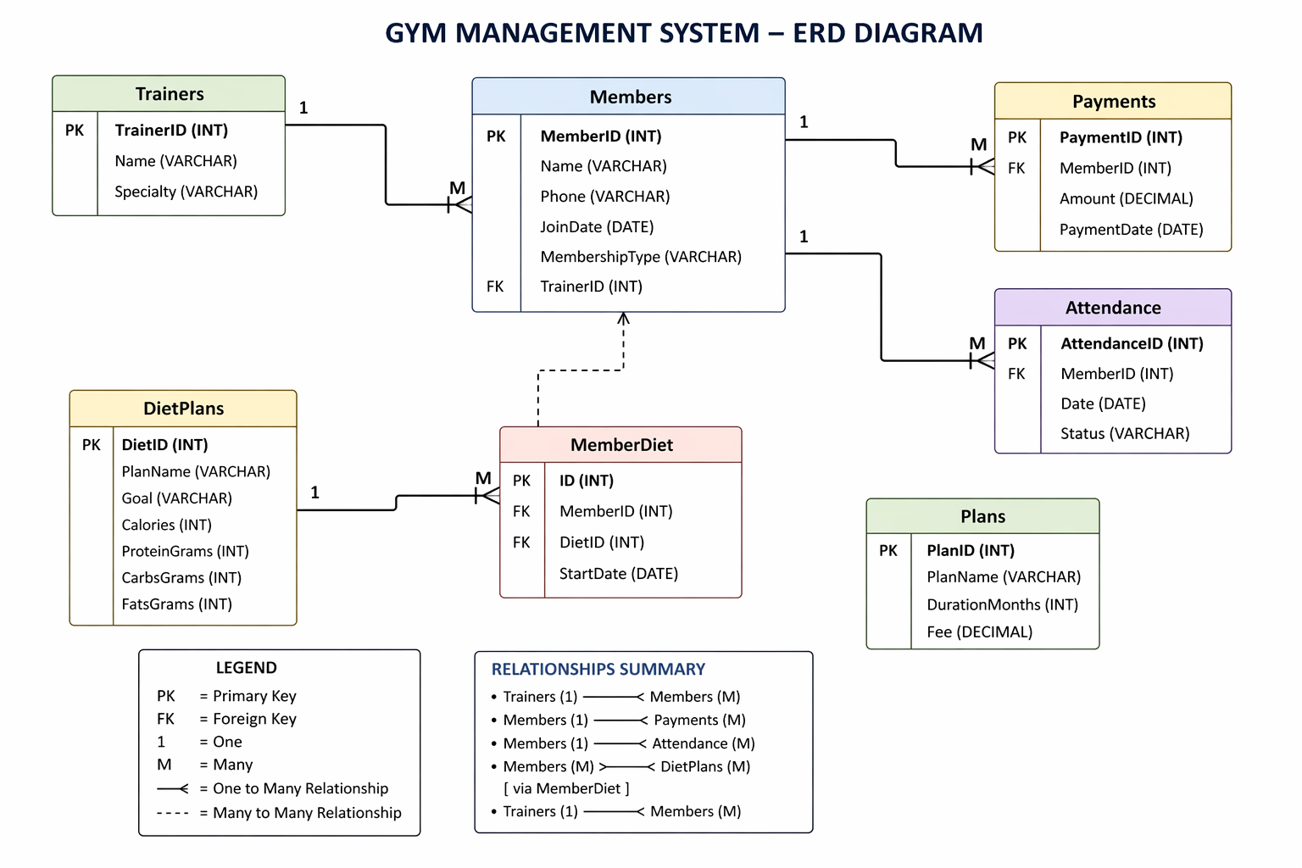

ERD Diagram Explanation
The system consists of six main entities:
- Members
- Trainers
- Payments
- Attendance
- Diet Plans
- Member Diet
Relationships:
- Members → Payments (1 to Many)
- Members → Attendance (1 to Many)
- Members → DietPlans (Many to Many via MemberDiet)
- Members → Trainers

DDL (Data Definition Language)

Create Database:

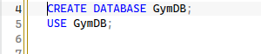

Members Table:

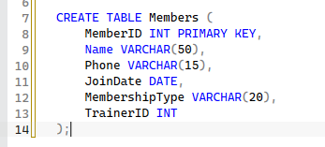

Trainers Table:

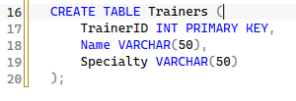

Payments Table:

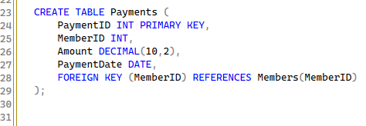

Attendance Table:

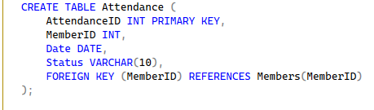

Diet Plans Table

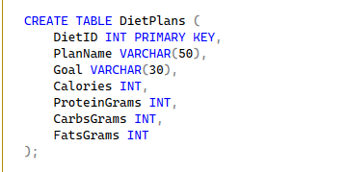

Members Diet Table

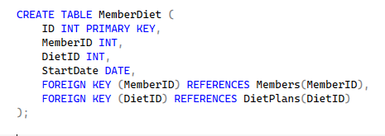

DML (Data Manipulation Language)
DML commands are used to insert, update, delete, and retrieve data from the database tables.

INSERT – Adding Data

Purpose
The INSERT statement is used to add new records into tables.

Explanation
- Data is inserted into different tables such as Customers, Accounts, Transactions, Loans, Users, and Passwords
- Each row represents a new record in the database

Example
INSERT INTO Customers (name, cnic, phone, address)
VALUES ('Ali Khan', '12345-1234567-1', '03001234567', 'Lahore');

Working
- A new customer record is created
- Values are stored in respective columns

UPDATE – Modifying Data

Purpose
The UPDATE statement is used to modify existing data in a table.

Explanation
- It changes values of specific columns
- A WHERE condition is used to target a specific record

Example
UPDATE Accounts
SET balance = balance + 5000
WHERE account_no = 1;

Working
- Adds 5000 to the balance of account number 1 Only that specific record is updated

DELETE – Removing Data

Purpose
The DELETE statement is used to remove records from a table.

Explanation
- Deletes data permanently
- WHERE clause ensures only selected record is removed

Example
DELETE FROM BankTransactions
WHERE transaction_id = 2;

Working
- Removes the transaction with ID 2
- Other records remain unchanged

SELECT – Retrieving Data

Purpose
The SELECT statement is used to retrieve and display data from tables.

Explanation
- Used to view stored data
- Can fetch all or specific records

Example
SELECT * FROM Customers;

Working
- Displays all records from Customers table

Additional SELECT Examples
SELECT * FROM Accounts;
SELECT * FROM BankTransactions;
SELECT * FROM Loans;

Conclusion of DML
DML commands are essential for handling data in the database.
- INSERT adds new data
- UPDATE modifies existing data
- DELETE removes unwanted data
- SELECT retrieves data for viewing
These operations ensure that the system can efficiently manage and manipulate banking information.
Screenshots :
Insert Data

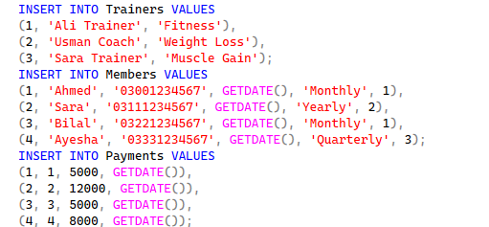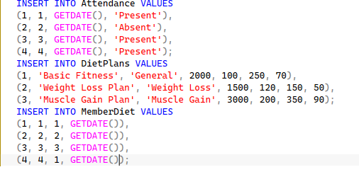

Update Data

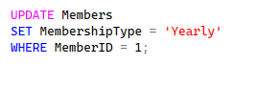

Delete Data

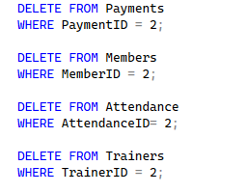

Select Queries:

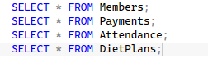

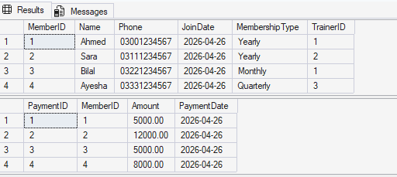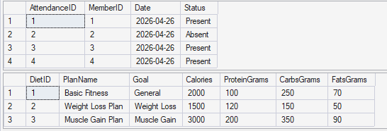

Aggregate Functions

Description
Aggregate functions are used in SQL to perform calculations on multiple rows of data and return a single result. These functions are commonly used for analysis, reporting, and summarizing data stored in database tables.
In the Gym Management System, aggregate functions help in analyzing financial data, tracking member activity, and generating useful insights such as total revenue, average payments, and attendance statistics.

Common Aggregate Functions Used

1. SUM()
Purpose:
Calculates the total value of a numeric column.
Example:
SELECT SUM(Amount) AS TotalRevenue
FROM Payments;
Explanation:
Adds all payment amounts to calculate total revenue generated by the gym.

2. AVG()
Purpose:
Calculates the average value of a column.
Example:
SELECT AVG(Amount) AS AveragePayment
FROM Payments;
Explanation:
Finds the average payment made by members.
3. COUNT()
Purpose:
Counts the total number of records.
Example:
SELECT COUNT(*) AS TotalMembers
FROM Members;
Explanation:
Counts the total number of registered gym members.

4. MAX()
Purpose:
Finds the highest value in a column.
Example:
SELECT MAX(Amount) AS HighestPayment
FROM Payments;
Explanation:
Returns the maximum payment made by any member.

5. MIN()
Purpose:
Finds the lowest value in a column.
Example:
SELECT MIN(Amount) AS LowestPayment
FROM Payments;
Explanation:
Returns the minimum payment amount.

GROUP BY with Aggregate Functions
Purpose:
Used to group data and apply aggregate functions to each group.
Example:
SELECT MemberID, SUM(Amount) AS TotalPayment
FROM Payments
GROUP BY MemberID;
Explanation:
Calculates total payment made by each member separately.

HAVING Clause
Purpose:
Used to filter grouped data.
Example:
SELECT MemberID, SUM(Amount) AS TotalPayment
FROM Payments
GROUP BY MemberID
HAVING SUM(Amount) > 5000;
Explanation:
Displays only those members whose total payment is greater than 5000.

Conclusion of Aggregate Functions

Functions are essential for data analysis in the Gym Management System. They help in summarizing large amounts of data into meaningful information.
- SUM calculates total values
- AVG finds average values
- COUNT counts records
- MAX and MIN find extreme values
These functions improve decision-making and allow efficient reporting of gym operations such as revenue and member activity.
Screenshots:
Total Payment of All Members:
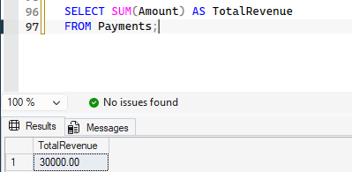
Average Payment:
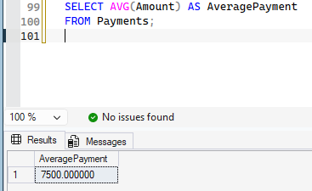
Maximum Payment:
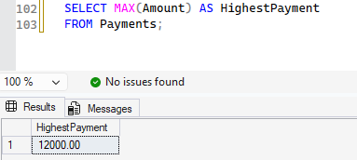
Group By:
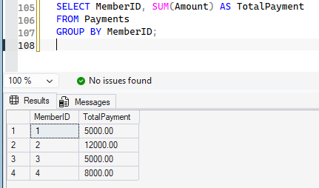
Having Clause :
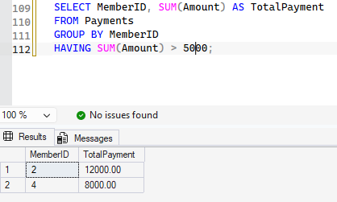

STORED PROCEDURES

Add Member
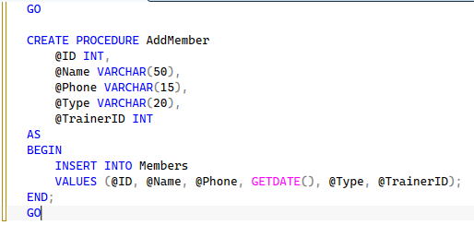
Add Payment :
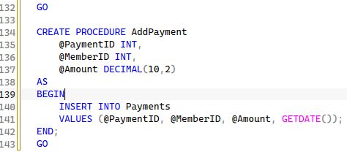

TRIGGERS

Prevent Negative Payment:

This trigger is used to prevent invalid payment entries. It checks if the inserted payment amount is negative and blocks such records. This ensures data integrity and prevents incorrect financial data from being stored.

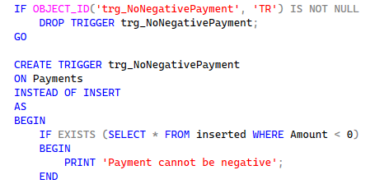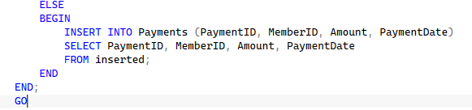

USER DEFINED FUNCTIONS

Description
User Defined Functions (UDFs) are custom functions created in SQL to perform specific tasks and return a value. They help in simplifying complex queries, improving code reusability, and making data retrieval more efficient.
In the Gym Management System, UDFs are used to perform calculations such as total payments of members, membership duration, and retrieving assigned diet plans.

Types of Functions Used
- Scalar Functions (return single value)

Function: Total Payment of a Member

Purpose
To calculate the total amount paid by a specific member.
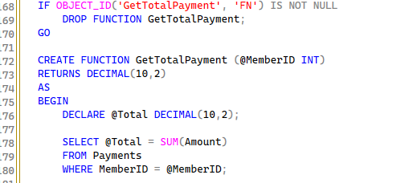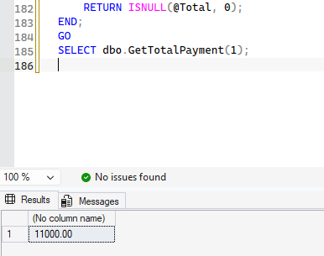

Working
- Takes MemberID as input
- Calculates sum of all payments
- Returns total amount

Function: Membership Duration

Purpose
To calculate how many days a member has been registered in the gym.

Code

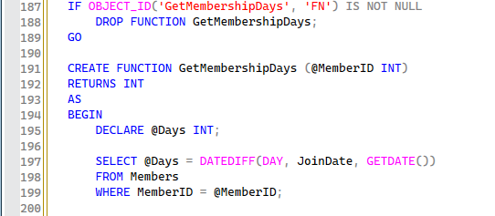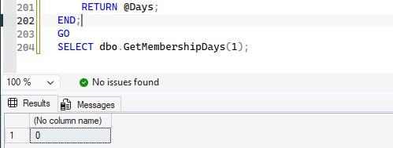

Working
- Takes MemberID as input
- Calculates difference between JoinDate and current date
- Returns number of days

Function: Get Member Diet Plan

Purpose
To retrieve the diet plan assigned to a member.

Code

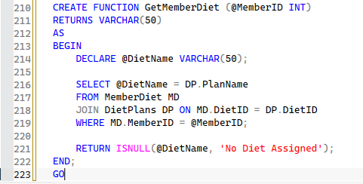

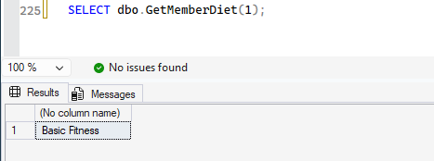

Working
- Joins MemberDiet and DietPlans tables
- Retrieves diet plan name
- Returns assigned diet or default message
User Defined Functions improve the efficiency of the Gym Management System by simplifying calculations and data retrieval. They reduce query complexity and provide reusable logic for common operations such as payment calculation, membership tracking, and diet management

GROUP BY:

Purpose
The GROUP BY clause is used to group rows that have the same values in specified columns and apply aggregate functions on them.

Example
SELECT MemberID, SUM(Amount) AS TotalPayment
FROM Payments
GROUP BY MemberID;

Explanation
- Groups payment records by MemberID
- Calculates total payment for each member

Working
Each member’s payments are combined, and the total amount is calculated separately.
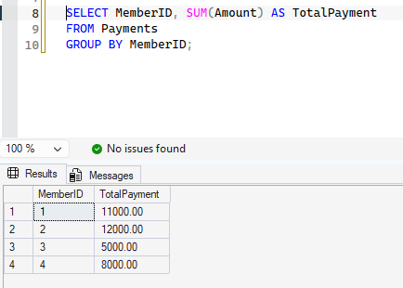
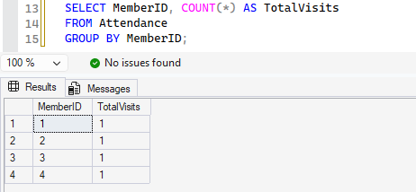
ORDER BY :

Purpose
The ORDER BY clause is used to sort the result set in ascending or descending order.

Example
SELECT * FROM Members
ORDER BY Name ASC;

Explanation
- Sorts members alphabetically by name

Working
All records are displayed in sorted order, making data easier to read and analyze.

Another Example
SELECT * FROM Payments
ORDER BY Amount DESC;
- Displays highest payments first
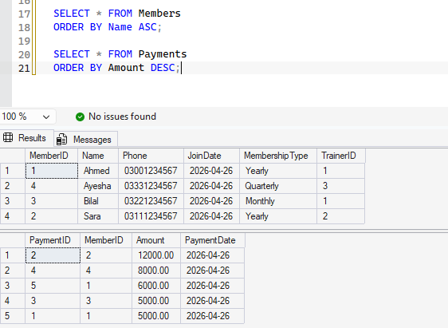

JOINS :

Purpose
Joins are used to combine data from multiple tables based on related columns.

INNER JOIN

Example
SELECT M.Name, P.Amount
FROM Members M
INNER JOIN Payments P ON M.MemberID = P.MemberID;

Explanation
- Combines Members and Payments tables
- Shows member name with their payment
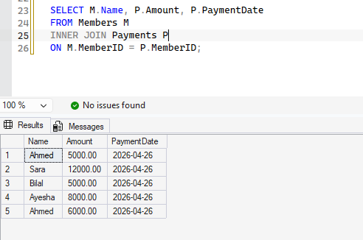

LEFT JOIN

Example
SELECT M.Name, P.Amount
FROM Members M
LEFT JOIN Payments P ON M.MemberID = P.MemberID;

Explanation
- Shows all members
- Includes payment data if available
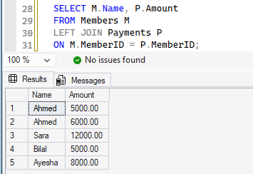

JOIN with DietPlans
SELECT M.Name, DP.PlanName
FROM Members M
JOIN MemberDiet MD ON M.MemberID = MD.MemberID
JOIN DietPlans DP ON MD.DietID = DP.DietID;

Explanation
- Combines three tables
- Displays member with assigned diet plan
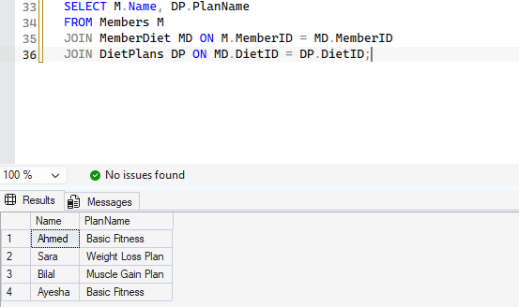

STORED PROCEDURES:

Purpose
Stored procedures are pre-defined SQL statements used to perform specific tasks. They improve efficiency and reduce repetition.

Example: Add Member

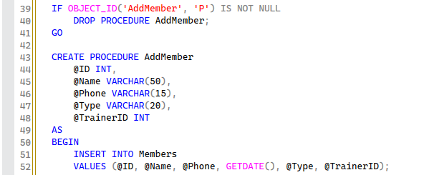

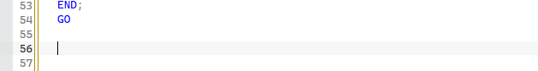

Explanation
- Inserts a new member into the database
- Uses parameters for dynamic input

Execution

VIEWS:

Purpose
A view is a virtual table created from a query. It simplifies complex queries and improves security.

Example: Member Payment View

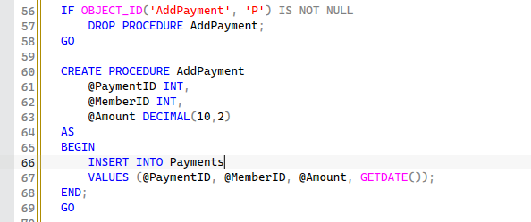

Explanation
- Combines member and payment data
- Acts like a table for easy access

Using View
SELECT * FROM MemberPayments;

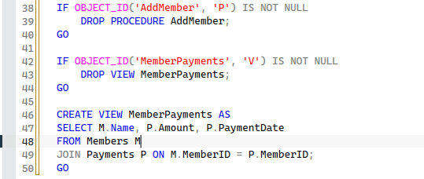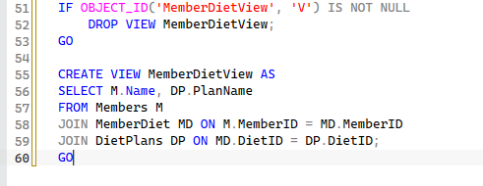

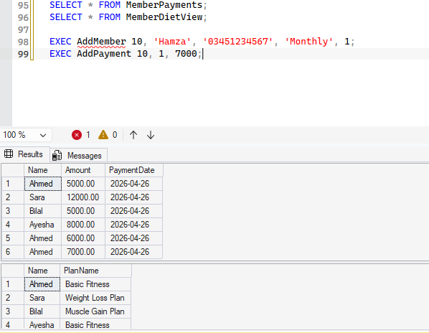

CONCLUSION
This document demonstrates the practical implementation of important database concepts within the Gym Management System.
- GROUP BY is used for data grouping and aggregation
- ORDER BY helps in sorting data
- JOINS combine data from multiple tables
- Stored Procedures automate operations
- Views simplify complex queries
These concepts improve efficiency, data organization, and overall system performance.

